CSIT314 Software Development Methodologies - Group Project

Sprint 1 - US6: Suspend user profile
Interior Design Platform - User Admin
All diagrams were drawn in draw.io. Open "US6 Suspend user profile.drawio" in this folder to edit them - each diagram is its own page in that file. The exported images are in the "diagrams" folder.

Assumptions
- The system is the Interior Design Platform from the project specification. This sprint covers the User Admin's log in / log out and managing user profiles.
- A user profile is a user group, e.g. User Admin, Interior Designer, Customer or Platform Manager. It has a name, a description, a list of permissions (what its users can do) and a status (Active or Suspended). Every user account belongs to exactly one user profile and gets that profile's permissions.
- We follow B-C-E: the actor only talks to the boundary (page), the boundary only talks to the controller, and the controller works with the entity classes. There is one controller per use case.
- Simple input checks (empty fields, length) are done in the boundary. Business rules (e.g. unique names) are done in the controller. Entity classes read and write the database.
- Suspending only changes the profile's status to Suspended. Nothing is deleted - the profile and all its user accounts are kept.
- Log in (US1) checks the profile's status, so this is what stops the group's users from logging in.
- The User Admin can't suspend their own profile, otherwise they could lock every admin out of the system. The page gets the logged-in admin's profile id from the session and passes it to the controller as adminProfileId.
- A profile that is already suspended can't be suspended again. Making a profile active again is not part of this sprint.

1. User story
Story ID | US6
User story | As a user admin, I want to suspend a user profile so that users in that group cannot log in.
Actor | User Admin
Priority | Medium
Story points (estimate) | 3
Acceptance criteria | 1. Given I am viewing an active user profile that isn't my own, there is a "Suspend" button.  2. Given I click "Suspend", then a confirmation box tells me which group will be suspended and that its users won't be able to log in.  3. Given I confirm, then the status changes to "Suspended" and I see "User profile suspended successfully".  4. Given a profile is suspended, when any user in that group tries to log in, then they can't (they get the login error).  5. Users in other groups can still log in, and no profile or user account is deleted.  6. Given I click "Cancel" in the confirmation box, then nothing changes.  7. I can't suspend a profile that is already suspended, or my own User Admin profile.
Tasks | T6.1 Write the use case description and draw the use case diagram  T6.2 Draw the B-C-E class diagram and the sequence diagram  T6.3 Draw the wireframes for the Suspend button, the confirmation box, the suspended profile and the blocked login  T6.4 Write the unit tests first (TDD) for UserProfile.suspendUserProfile() and SuspendUserProfileController  T6.5 Code UserProfile.isActive() and suspendUserProfile()  T6.6 Code SuspendUserProfileController (already suspended / own profile checks)  T6.7 Code SuspendUserProfilePage: Suspend button, confirmation box and messages  T6.8 Check that LoginController (US1) refuses users whose profile is suspended  T6.9 Run the test cases, fix bugs and push to the repo so the CI pipeline runs the unit tests

2. Use case diagram
The user story becomes one use case, UC6 Suspend user profile. The User Admin is the only actor.
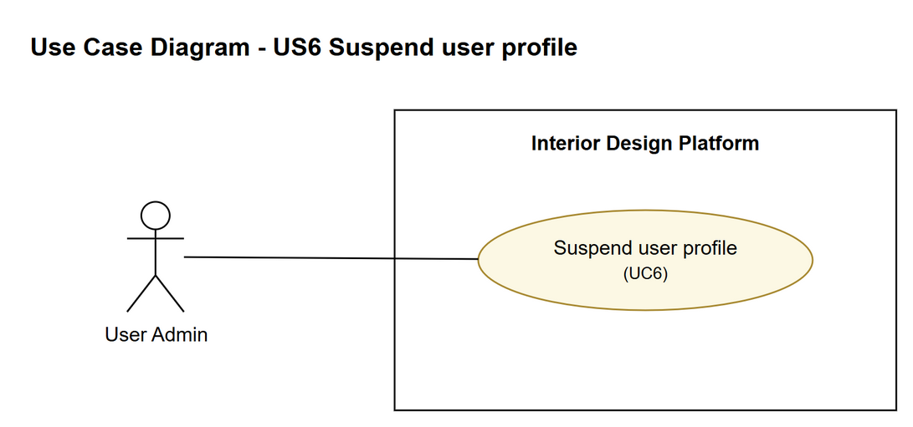
Figure 1: Use case diagram for US6 Suspend user profile

3. Use case description
Use case | UC6 Suspend user profile
Actor | User Admin
Brief description | The User Admin suspends a user group so that none of its users can log in. Nothing is deleted.
User story | US6: As a user admin, I want to suspend a user profile so that users in that group cannot log in.
Preconditions | The User Admin is logged in (UC1).  The User Admin is viewing an active user profile that is not their own (UC4).
Trigger | The User Admin clicks "Suspend" on the user profile's details page.
Basic flow | 1. The User Admin clicks "Suspend".  2. The system asks the User Admin to confirm, saying which group will be suspended and that its users won't be able to log in.  3. The User Admin clicks "Suspend" to confirm.  4. The system checks that the profile is active and is not the User Admin's own profile.  5. The system changes the profile's status to "Suspended". The profile and its user accounts are kept.  6. The system shows "User profile suspended successfully" and the profile with status Suspended.
Alternative flows | 3a. The User Admin clicks "Cancel": the confirmation box closes and nothing changes.  4a. The profile is already suspended, or it is the User Admin's own profile: the system shows "This user profile cannot be suspended" and nothing changes. (Normally the Suspend button isn't even shown in these cases.)
Postconditions | The user profile's status is "Suspended".  Users whose account is in this profile can no longer log in (UC1, alternative flow 7a).  No profile or user account is deleted.

4. Wireframes
The wireframes were drawn in draw.io. They are low-fidelity: they show the layout and the flow, not the final colours. The orange numbers match the notes under each screen.

4a - Suspend button on the details page
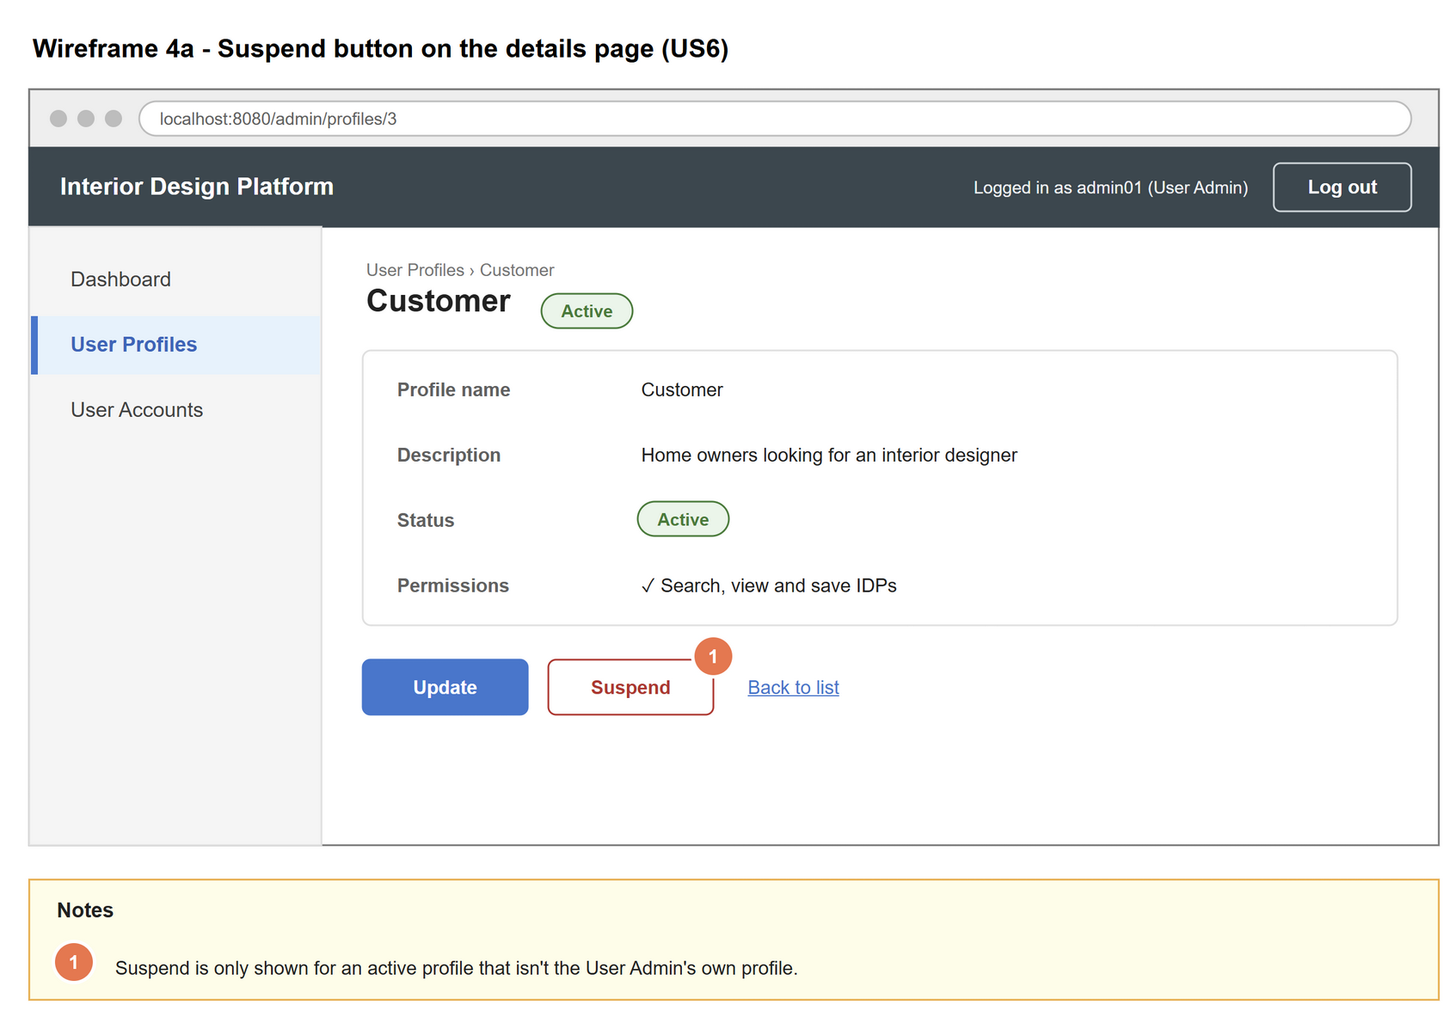
Figure 2: Wireframe 4a - Suspend button on the details page (US6)

4b - Confirmation box
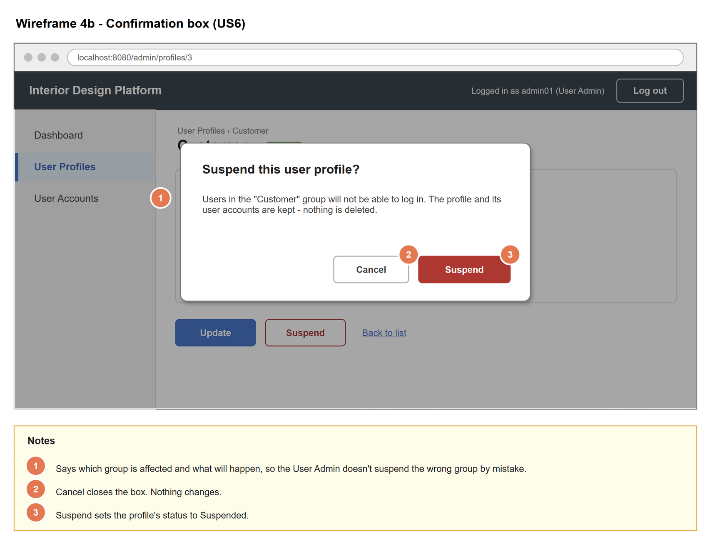
Figure 3: Wireframe 4b - Confirmation box (US6)

4c - User profile suspended
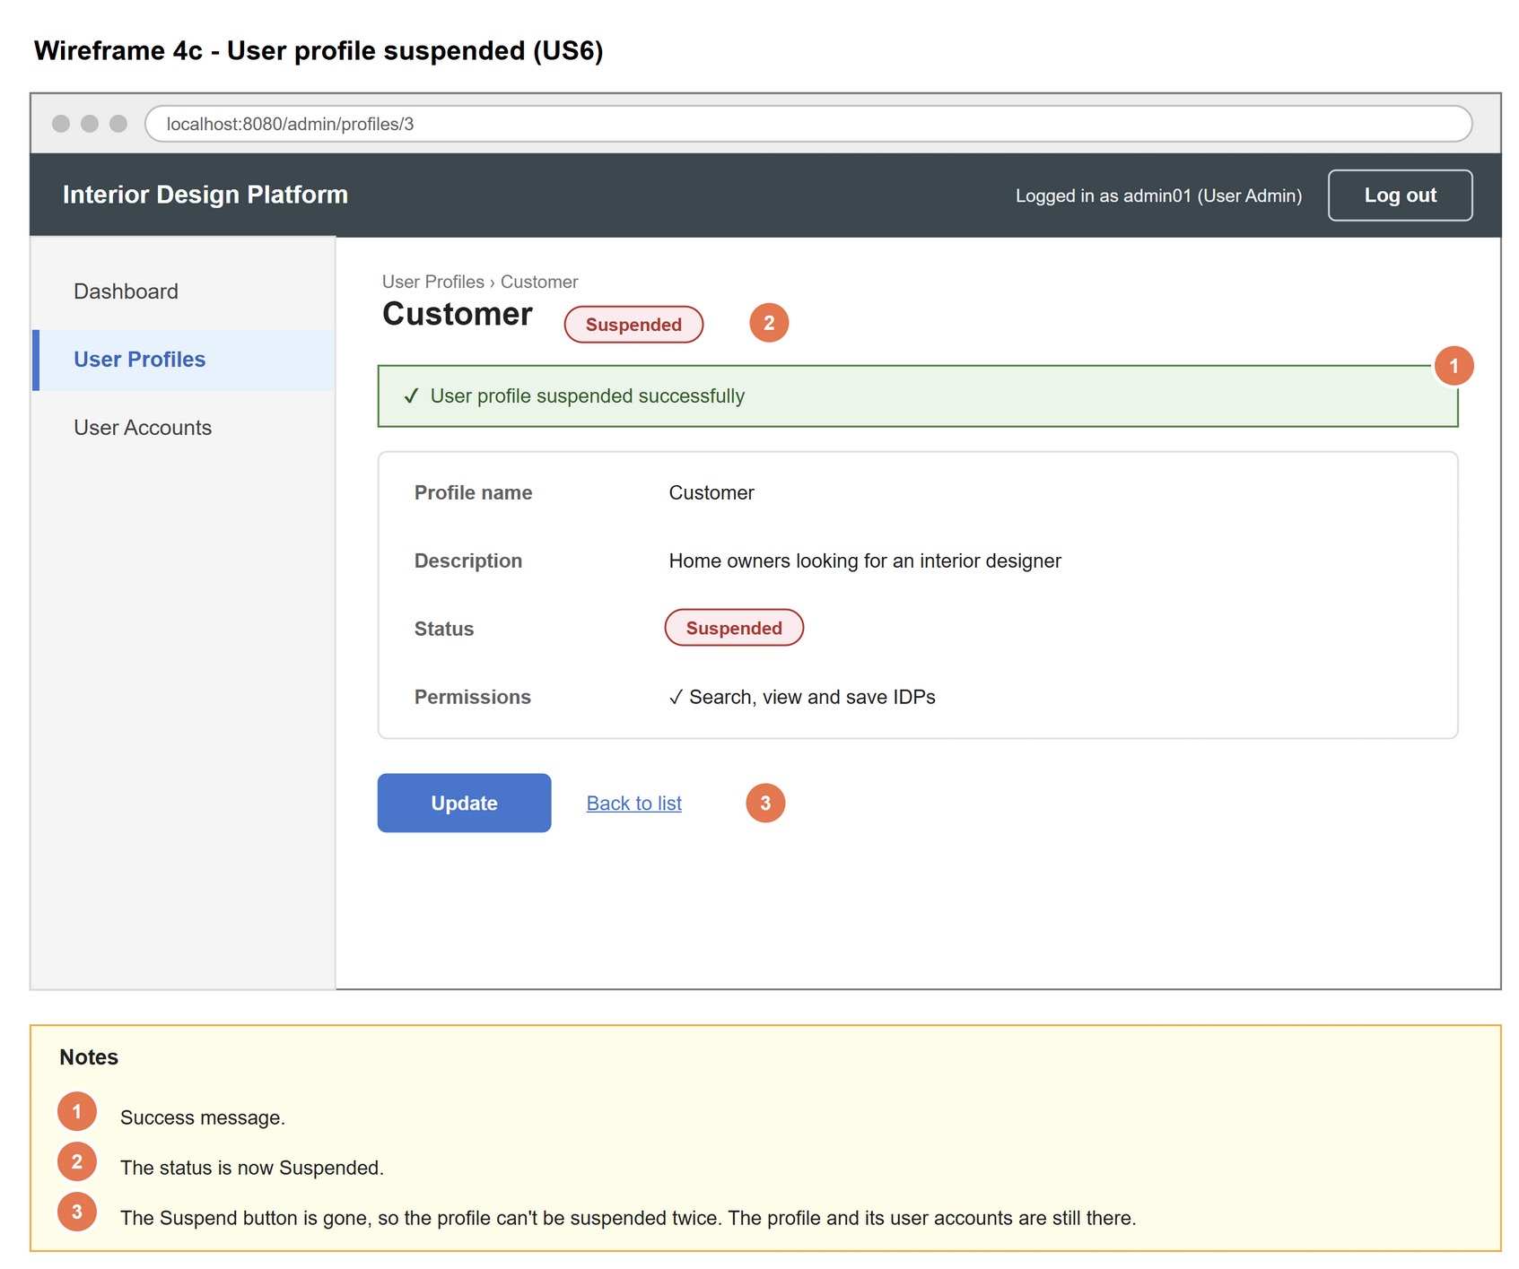
Figure 4: Wireframe 4c - User profile suspended (US6)

4d - A user in the suspended group tries to log in
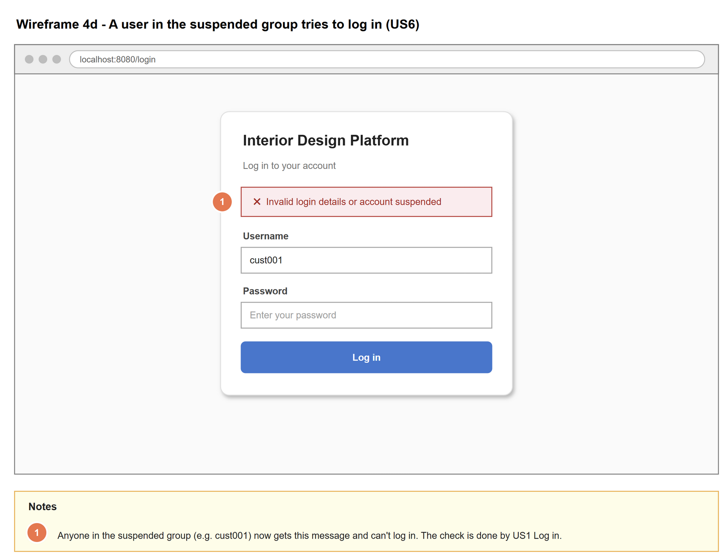
Figure 5: Wireframe 4d - A user in the suspended group tries to log in (US6)

5. B-C-E class diagram
The solid arrow means the boundary calls the controller. The dashed arrows mean the controller uses the entity class. Only the operations needed for this use case are shown.
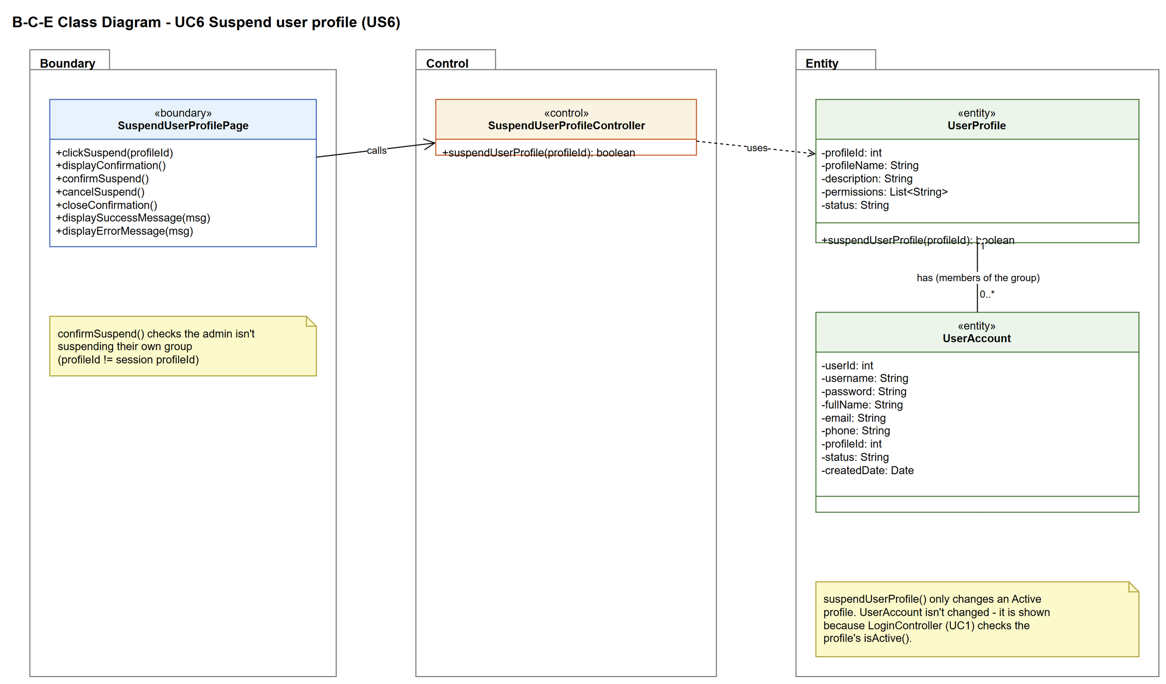
Figure 6: B-C-E class diagram for US6 Suspend user profile
Layer | Class | What it does
Boundary | SuspendUserProfilePage | The Suspend button and the confirmation box on the profile details page. Passes the profile id and the logged-in admin's profile id to the controller and shows the result.
Control | SuspendUserProfileController | Controller for UC6. Applies the business rules: the profile must be active and must not be the admin's own profile. Then asks UserProfile to suspend it.
Entity | UserProfile | The user group. suspendUserProfile() changes the status to Suspended; isActive() is also what Log in uses to refuse the group's users.
Entity | UserAccount | Not changed. Shown for the 1 to 0..* relationship: every account in the suspended profile is blocked from logging in.

6. Sequence diagram
The sequence diagram follows UC6. After the confirmation box is shown (step 2), the outer alt has the two choices: confirm (step 3) or cancel (alternative flow 3a). When confirmed, the controller gets the profile and checks it is active and not the admin's own profile (step 4). Only then is the status changed (opt box, step 5). The inner alt shows the success message (step 6) or the error message (alternative flow 4a).
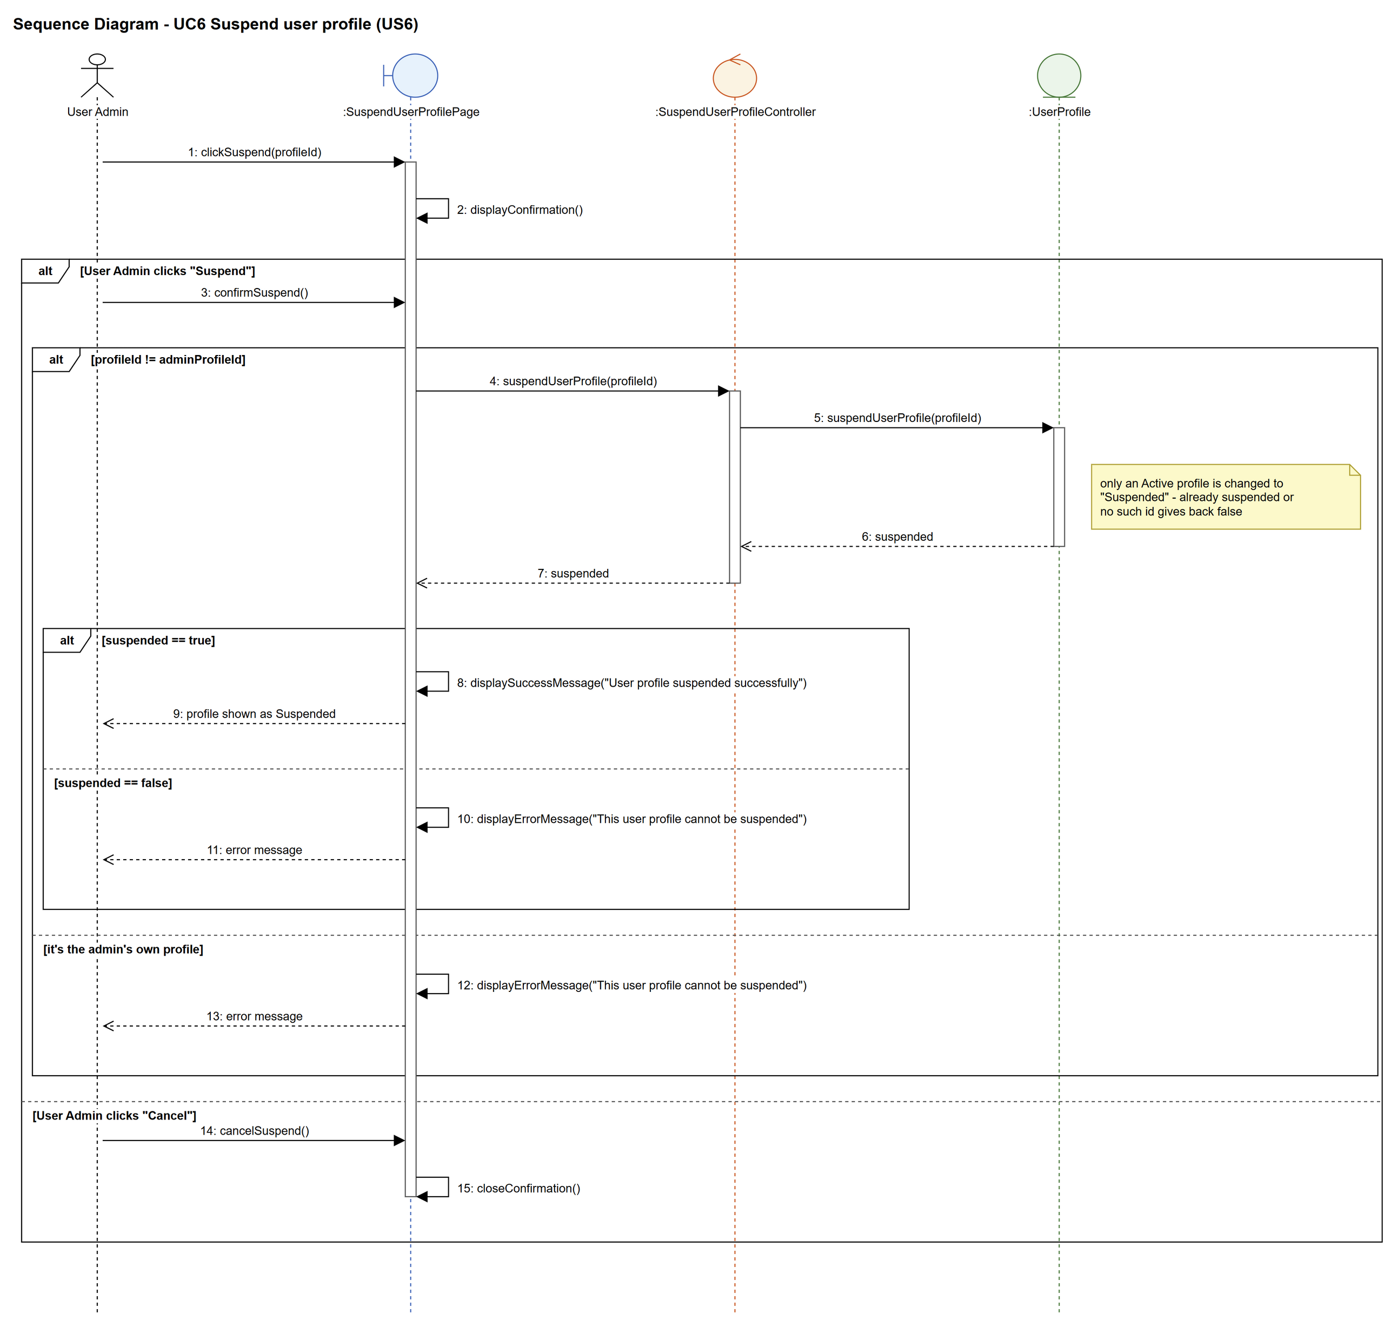
Figure 7: Sequence diagram for UC6 Suspend user profile

7. Test cases
Test data used below: user profiles User Admin (id 1), Interior Designer (id 2), Customer (id 3) and Platform Manager (id 4), all Active. User accounts admin01 / Admin@123 (User Admin, Active), admin02 / Admin@123 (User Admin, Suspended), des001 / Des@123 (Interior Designer, Active) and cust001 / Cust@123 (Customer, Active).

7a. System test cases (black box)
Equivalence partitioning and boundary value analysis were used to pick the test data. Fill in "Actual result" and "Pass/Fail" after running each test.
Test ID | Scenario | Prerequisites | Test steps | Test data | Expected result | Actual result | Pass / Fail
TC6.1 | Suspend an active profile | Logged in as admin01. Customer is Active. cust001 is in Customer. | 1. View Customer  2. Click "Suspend"  3. Click "Suspend" in the confirmation box | Profile: Customer (id 3) | "User profile suspended successfully". Status is Suspended. The Suspend button is no longer shown.
TC6.2 | A user in the suspended group can't log in | TC6.1 done. | 1. Log out  2. Log in as cust001 | cust001 / Cust@123 | "Invalid login details or account suspended". Not logged in.
TC6.3 | Other groups are not affected | TC6.1 done. | 1. Log in as des001 | des001 / Des@123 | des001 logs in normally.
TC6.4 | Nothing is deleted | TC6.1 done. | 1. Open the User Profiles list  2. Check the user_account table | Profile: Customer (id 3) | Customer is still in the list (Suspended). cust001 still exists.
TC6.5 | Cancel the suspend | Customer is Active. | 1. View Customer  2. Click "Suspend"  3. Click "Cancel" | Profile: Customer (id 3) | The box closes. Status is still Active.
TC6.6 | Confirmation names the group | Customer is Active. | 1. View Customer  2. Click "Suspend" | Profile: Customer (id 3) | The box says users in the "Customer" group will not be able to log in.
TC6.7 | Already suspended profile | Customer is Suspended. | 1. View Customer | Profile: Customer (id 3) | No Suspend button is shown.
TC6.8 | Own profile | Logged in as admin01 (User Admin profile). | 1. View User Admin | Profile: User Admin (id 1) | No Suspend button is shown. The User Admin profile stays Active.

7b. Unit test cases (for TDD)
These are written before the code (test-driven development) and run automatically in the CI pipeline. They cover normal inputs, abnormal inputs and boundary values.
Test ID | Class and method | Input / setup | Expected output | Type | Pass / Fail
UT6.1 | SuspendUserProfileController.suspendUserProfile() | 3, 1 | Returns true. getUserProfile(3) has status "Suspended". | Normal
UT6.2 | SuspendUserProfileController.suspendUserProfile() | 3, 1 (Customer already Suspended) | Returns false | Abnormal
UT6.3 | SuspendUserProfileController.suspendUserProfile() | 1, 1 (admin's own profile) | Returns false. Profile 1 is still Active. | Abnormal
UT6.4 | SuspendUserProfileController.suspendUserProfile() | 9999, 1 | Returns false (no error thrown) | Abnormal
UT6.5 | UserProfile.isActive() | Customer after UT6.1 | Returns false | Normal
UT6.6 | LoginController.login() | "cust001", "Cust@123" after UT6.1 | Returns null (can't log in) | Normal
UT6.7 | UserProfile.suspendUserProfile() | 3 | The number of user accounts with profileId 3 is the same before and after | Normal

